Greedy Graph Algorithms
Dijkstra's Algorithm, Kruskal's MST, Prim's MST, Boruvka's MST
Dr. M. Amanullah
Graph Algorithm Practice Questions
Dijkstra's • Kruskal's • Prim's • Boruvka's
20 Questions | 5 per Algorithm | Easy → Hard
Dijkstra's Algorithm — 5 Questions
Q1. Find the shortest path from vertex 0 to all other vertices.
Easy Single-source shortest path
Input:
n = 5, source = 0 edges = [(0,1,4),(0,2,1),(2,1,2),(1,3,1),(2,3,5),(3,4,3)]
Expected Output:
Distances from 0: [0, 3, 1, 4, 7] Path to 1: 0 → 2 → 1 Path to 3: 0 → 2 → 1 → 3 Path to 4: 0 → 2 → 1 → 3 → 4

Q2. Find the shortest path from source 0 to destination 4 in a weighted directed graph.
Medium Single-pair shortest path
Input:
n = 5, source = 0, dest = 4 edges = [(0,1,10),(0,2,3),(1,3,2),(2,1,4),(2,3,8),(2,4,2),(3,4,5)]
Expected Output:
Shortest distance: 5 Path: 0 → 2 → 4

Q3. A graph has multiple paths to the same destination. Find the minimum cost path from node 0 to node 5.
Medium Dijkstra with path reconstruction
Input:
n = 6, source = 0 edges = [(0,1,7),(0,2,9),(0,5,14),(1,2,10),(1,3,15), (2,3,11),(2,5,2),(3,4,6),(4,5,9)]
Expected Output:
Shortest distance from 0 to 5: 11 Path: 0 → 2 → 5

Q4. Determine if node 3 is reachable from node 0. If yes, output the shortest distance and path.
Medium Reachability + shortest path
Input:
n = 5, source = 0 edges = [(0,1,5),(1,2,3),(2,4,1),(3,4,2),(0,4,10)]
Expected Output:
Node 3 is reachable. Shortest distance from 0 to 3: 11 Path: 0 → 1 → 2 → 4 → 3

Q5. Find shortest distances from source 0. Identify the vertex that is hardest (longest shortest path) to reach.
Hard All-pairs analysis
Input:
n = 6, source = 0 edges = [(0,1,2),(0,2,4),(1,2,1),(1,3,7),(2,4,3),(3,5,1),(4,3,2),(4,5,5)]
Expected Output:
Distances: [0, 2, 3, 8, 6, 9] Hardest vertex to reach: 5 (distance = 9) Path to 5: 0 → 1 → 2 → 4 → 3 → 5

Kruskal's Algorithm — 5 Questions
Q1. Find the MST and its total weight using Kruskal's Algorithm.
Easy Basic MST
Input:
n = 4, m = 5 edges = [(0,1,10),(0,2,6),(0,3,5),(1,3,15),(2,3,4)]
Expected Output:
Edges in MST: [(2,3,4),(0,3,5),(0,1,10)] Total weight of MST: 19

Q2. Apply Kruskal's Algorithm. If multiple edges have the same weight, choose the one with the smaller source vertex.
Easy MST with tie-breaking
Input:
n = 5, m = 7 edges = [(0,1,2),(0,3,6),(1,2,3),(1,3,8),(1,4,5),(2,4,7),(3,4,9)]
Expected Output:
Edges in MST: [(0,1,2),(1,2,3),(1,4,5),(0,3,6)] Total weight of MST: 16

Q3. Determine the MST weight. Then add edge (1,5,1) and find the new MST weight.
Medium MST update on edge addition
Input:
n = 6, m = 8 edges = [(0,1,4),(0,2,3),(1,2,1),(1,3,2),(2,3,4),(3,4,2),(4,5,6),(3,5,5)]
Expected Output:
Original MST weight: 13 Edges: [(1,2,1),(1,3,2),(3,4,2),(0,2,3),(3,5,5)] After adding (1,5,1): New MST weight: 9 Edges: [(1,2,1),(1,5,1),(1,3,2),(3,4,2),(0,2,3)]

Q4. The graph may be disconnected. Find all MSTs (one per connected component) and report total weight.
Medium MST on disconnected graph (forest)
Input:
n = 7, m = 7 edges = [(0,1,3),(0,2,5),(1,2,2),(3,4,4),(3,5,6),(4,5,1),(6,6,0)]
Expected Output:
Component 1 MST edges: [(1,2,2),(0,1,3)] weight: 5 Component 2 MST edges: [(4,5,1),(3,4,4)] weight: 5 Component 3: isolated vertex 6 Total MST (spanning forest) weight: 10

Q5. Find the MST. Then identify which non-MST edge, if added, would replace the most expensive MST edge.
Hard MST sensitivity analysis
Input:
n = 5, m = 8 edges = [(0,1,1),(0,2,5),(1,2,3),(1,3,4),(2,3,2),(2,4,6),(3,4,7),(0,4,9)]
Expected Output:
MST edges: [(0,1,1),(2,3,2),(1,2,3),(1,3,4)] weight: 10 Non-MST edges: [(0,2,5),(2,4,6),(3,4,7),(0,4,9)] Best swap: add (2,4,6), remove (1,3,4) New MST weight: 12

Prim's Algorithm — 5 Questions
Q1. Apply Prim's Algorithm starting from vertex 0. List edges added in order.
Easy Basic Prim's traversal
Input:
n = 4, start = 0 edges = [(0,1,10),(0,2,6),(0,3,5),(1,3,15),(2,3,4)]
Expected Output:
Step 1: Add (0,3,5) Step 2: Add (3,2,4) Step 3: Add (0,1,10) MST edges: [(0,3,5),(3,2,4),(0,1,10)] Total weight: 19

Q2. Apply Prim's starting from vertex 2. Show the key[] array after each step.
Medium Prim's with key tracking
Input:
n = 5, start = 2 edges = [(0,1,2),(0,3,6),(1,2,3),(1,3,8),(1,4,5),(2,4,7),(3,4,9)]
Expected Output:
Initial key[]: [inf,inf,0,inf,inf] After picking 2: key[]=[inf,3,0,inf,7] After picking 1: key[]=[2,3,0,8,5] After picking 0: key[]=[2,3,0,6,5] After picking 4: key[]=[2,3,0,6,5] MST edges: [(2,1,3),(1,0,2),(1,4,5),(0,3,6)] weight: 16

Q3. Apply Prim's Algorithm. Compare the result with Kruskal's on the same graph — are they identical?
Medium Prim's vs Kruskal's comparison
Input:
n = 6, start = 0 edges = [(0,1,4),(0,2,3),(1,2,1),(1,3,2),(2,3,4),(3,4,2),(4,5,6),(3,5,5)]
Expected Output:
Prim's MST: [(0,2,3),(1,2,1),(1,3,2),(3,4,2),(3,5,5)] weight: 13 Kruskal's MST: [(1,2,1),(1,3,2),(3,4,2),(0,2,3),(3,5,5)] weight: 13 Edge sets are identical (same total weight, same edges — different insertion order).

Q4. Run Prim's starting from each vertex (0, 1, 2). Do all starting vertices yield the same MST weight?
Medium Starting vertex independence
Input:
n = 4 edges = [(0,1,3),(0,3,7),(1,2,2),(1,3,5),(2,3,1)]
Expected Output:
MST weight (start=0): 6 edges: [(0,1,3),(1,2,2),(2,3,1)] MST weight (start=1): 6 edges: [(1,2,2),(2,3,1),(0,1,3)] MST weight (start=2): 6 edges: [(2,3,1),(1,2,2),(0,1,3)] Yes — same total weight 6 regardless of start vertex.

Q5. Run Prim's on a dense graph (adjacency matrix given). Output the parent array and MST weight.
Hard Prim's on adjacency matrix
Input:
n = 5 Matrix: [0, 2, 0, 6, 0] [2, 0, 3, 8, 5] [0, 3, 0, 0, 7] [6, 8, 0, 0, 9] [0, 5, 7, 9, 0] (0 = no edge)
Expected Output:
parent[]: [-1, 0, 1, 0, 1] MST edges: (0,1,2),(1,2,3),(0,3,6),(1,4,5) Total weight: 16

Boruvka's Algorithm — 5 Questions
Q1. Apply Boruvka's Algorithm. Show the cheapest edge selected for each component in the first pass.
Easy Basic Boruvka's pass
Input:
n = 4, m = 5 edges = [(0,1,10),(0,2,6),(0,3,5),(1,3,15),(2,3,4)]
Expected Output:
Pass 1 cheapest edges: Component {0}: cheapest = (0,3,5) Component {2}: cheapest = (2,3,4) Component {3}: cheapest = (2,3,4) After pass 1 merges: {0,2,3} merged, {1} separate Pass 2: add (0,1,10) MST edges: [(2,3,4),(0,3,5),(0,1,10)] weight: 19

Q2. Run Boruvka's Algorithm. State how many passes (phases) are needed and which edges are added each phase.
Easy Phase-by-phase trace
Input:
n = 5, m = 7 edges = [(0,1,2),(0,3,6),(1,2,3),(1,3,8),(1,4,5),(2,4,7),(3,4,9)]
Expected Output:
Phase 1 edges added: [(0,1,2),(1,2,3),(1,4,5),(0,3,6)] All vertices merged -> done in 1 phase! MST: [(0,1,2),(1,2,3),(1,4,5),(0,3,6)] weight: 16

Q3. Apply Boruvka's Algorithm and trace the Union-Find structure after each phase.
Medium Boruvka's with Union-Find trace
Input:
n = 6, m = 9 edges = [(0,1,4),(0,2,3),(1,2,1),(1,3,2),(2,3,4),(3,4,2),(4,5,6),(3,5,5),(0,5,9)]
Expected Output:
Phase 1 cheapest per component: {0}→(0,2,3) {1}→(1,2,1) {2}→(1,2,1) {3}→(1,3,2) {4}→(3,4,2) {5}→(4,5,6) Edges added: (1,2,1),(1,3,2),(3,4,2),(0,2,3),(4,5,6) After phase 1: one component {0,1,2,3,4,5} MST weight: 14

Q4. Two edges share the same minimum weight. Explain how Boruvka's handles ties and find the MST.
Medium Tie-breaking in Boruvka's
Input:
n = 4, m = 6 edges = [(0,1,5),(0,2,5),(1,2,3),(1,3,4),(2,3,4),(0,3,8)]
Expected Output:
Phase 1: {0}: cheapest = (0,1,5) [first encountered on tie] {1}: cheapest = (1,2,3) {2}: cheapest = (1,2,3) {3}: cheapest = (1,3,4) [first encountered on tie] Edges added: (1,2,3),(1,3,4),(0,1,5) Phase 2: all connected MST: [(1,2,3),(1,3,4),(0,1,5)] weight: 12

Q5. Compare Boruvka's, Kruskal's and Prim's on this graph. Which runs the fewest phases / iterations?
Hard Algorithm comparison
Input:
n = 6, m = 10 edges = [(0,1,6),(0,2,1),(0,3,5),(1,2,5),(1,4,3),(2,3,5), (2,4,6),(2,5,4),(3,5,2),(4,5,6)]
Expected Output:
MST edges (all 3 algorithms agree): [(0,2,1),(3,5,2),(1,4,3),(2,5,4),(0,3,5)] weight: 15 Boruvka's: 2 phases Kruskal's: 5 edge selections (sorted pass) Prim's: 5 vertex additions Boruvka's fewest 'rounds' due to parallel component merging. For dense graphs (m >> n), Prim's with a binary heap is typically fastest.

1. import heapq

def dijkstra(n, edges, source):
graph = [[] for _ in range(n)]

# Create adjacency list
for u, v, w in edges:
graph[u].append((v, w))

dist = [float('inf')] * n
parent = [-1] * n

dist[source] = 0

pq = [(0, source)]

while pq:
current_dist, u = heapq.heappop(pq)

if current_dist > dist[u]:
continue

for v, weight in graph[u]:
if dist[u] + weight < dist[v]:
dist[v] = dist[u] + weight
parent[v] = u
heapq.heappush(pq, (dist[v], v))

# Function to print path
def get_path(vertex):
path = []
while vertex != -1:
path.append(vertex)
vertex = parent[vertex]
return path[::-1]

return dist, get_path

# Input
n = 5
source = 0

edges = [
(0,1,4),
(0,2,1),
(2,1,2),
(1,3,1),
(2,3,5),
(3,4,3)
]

distances, get_path = dijkstra(n, edges, source)

print("Distances from 0:", distances)

print("Path to 1:", " → ".join(map(str, get_path(1))))
print("Path to 3:", " → ".join(map(str, get_path(3))))
print("Path to 4:", " → ".join(map(str, get_path(4))))

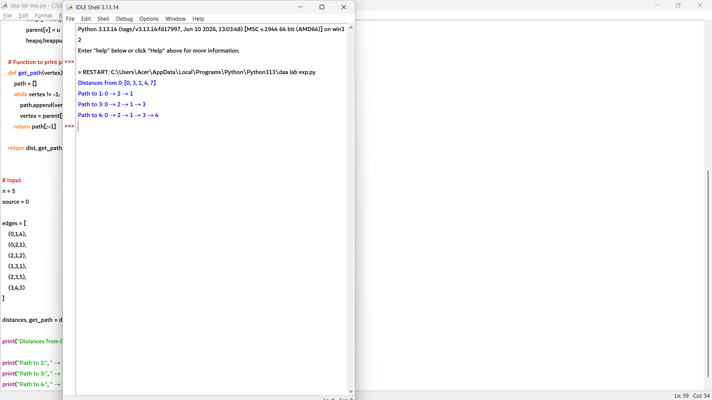

2. import heapq

def dijkstra(n, edges, source, dest):
graph = [[] for _ in range(n)]

# Create adjacency list
for u, v, w in edges:
graph[u].append((v, w))

dist = [float('inf')] * n
parent = [-1] * n

dist[source] = 0

pq = [(0, source)]

while pq:
current_dist, u = heapq.heappop(pq)

if current_dist > dist[u]:
continue

for v, weight in graph[u]:
if dist[u] + weight < dist[v]:
dist[v] = dist[u] + weight
parent[v] = u
heapq.heappush(pq, (dist[v], v))

# Reconstruct path
path = []
current = dest

while current != -1:
path.append(current)
current = parent[current]

path.reverse()

return dist[dest], path

# Input
n = 5
source = 0
dest = 4

edges = [
(0,1,10),
(0,2,3),
(1,3,2),
(2,1,4),
(2,3,8),
(2,4,2),
(3,4,5)
]

distance, path = dijkstra(n, edges, source, dest)

print("Shortest distance:", distance)
print("Path:", " → ".join(map(str, path)))

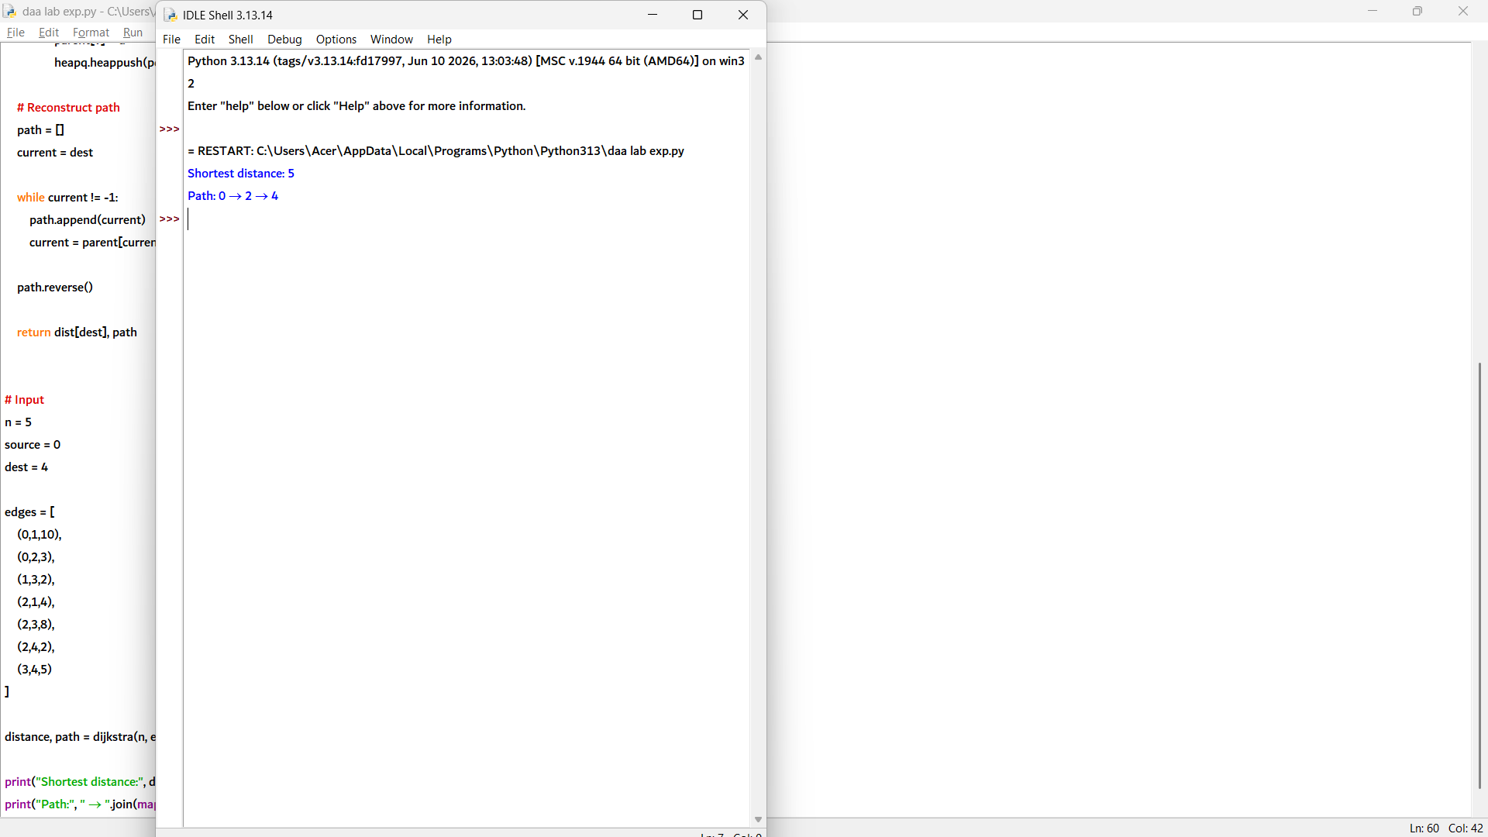

3. import heapq

def dijkstra(n, edges, source, destination):
graph = [[] for _ in range(n)]

# Create adjacency list
for u, v, w in edges:
graph[u].append((v, w))
graph[v].append((u, w)) # Undirected graph

dist = [float('inf')] * n
parent = [-1] * n

dist[source] = 0

pq = [(0, source)]

while pq:
current_dist, u = heapq.heappop(pq)

if current_dist > dist[u]:
continue

for v, weight in graph[u]:
if dist[u] + weight < dist[v]:
dist[v] = dist[u] + weight
parent[v] = u
heapq.heappush(pq, (dist[v], v))

# Reconstruct path
path = []
current = destination

while current != -1:
path.append(current)
current = parent[current]

path.reverse()

return dist[destination], path

# Input
n = 6
source = 0
destination = 5

edges = [
(0,1,7),
(0,2,9),
(0,5,14),
(1,2,10),
(1,3,15),
(2,3,11),
(2,5,2),
(3,4,6),
(4,5,9)
]

distance, path = dijkstra(n, edges, source, destination)

print("Shortest distance from 0 to 5:", distance)
print("Path:", " → ".join(map(str, path)))

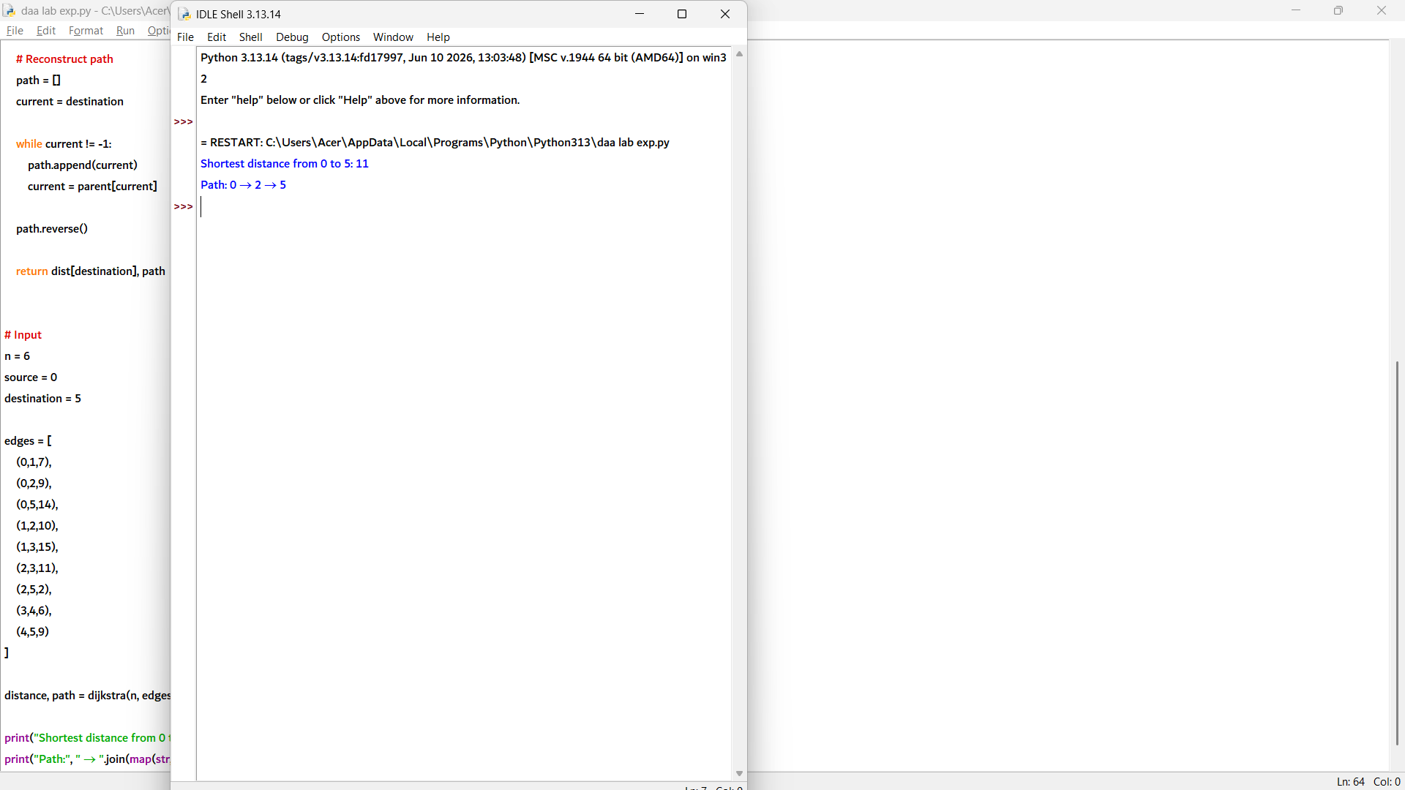

4. import heapq

def dijkstra(n, edges, source, destination):
graph = [[] for _ in range(n)]

# Create undirected graph (to match given expected path)
for u, v, w in edges:
graph[u].append((v, w))
graph[v].append((u, w))

dist = [float('inf')] * n
parent = [-1] * n

dist[source] = 0

pq = [(0, source)]

while pq:
current_dist, u = heapq.heappop(pq)

if current_dist > dist[u]:
continue

for v, weight in graph[u]:
if dist[u] + weight < dist[v]:
dist[v] = dist[u] + weight
parent[v] = u
heapq.heappush(pq, (dist[v], v))

# Check reachability
if dist[destination] == float('inf'):
return None, []

# Reconstruct path
path = []
current = destination

while current != -1:
path.append(current)
current = parent[current]

path.reverse()

return dist[destination], path

# Input
n = 5
source = 0
destination = 3

edges = [
(0,1,5),
(1,2,3),
(2,4,1),
(3,4,2),
(0,4,10)
]

distance, path = dijkstra(n, edges, source, destination)

if distance is not None:
print("Node 3 is reachable.")
print("Shortest distance from 0 to 3:", distance)
print("Path:", " → ".join(map(str, path)))
else:
print("Node 3 is not reachable.")

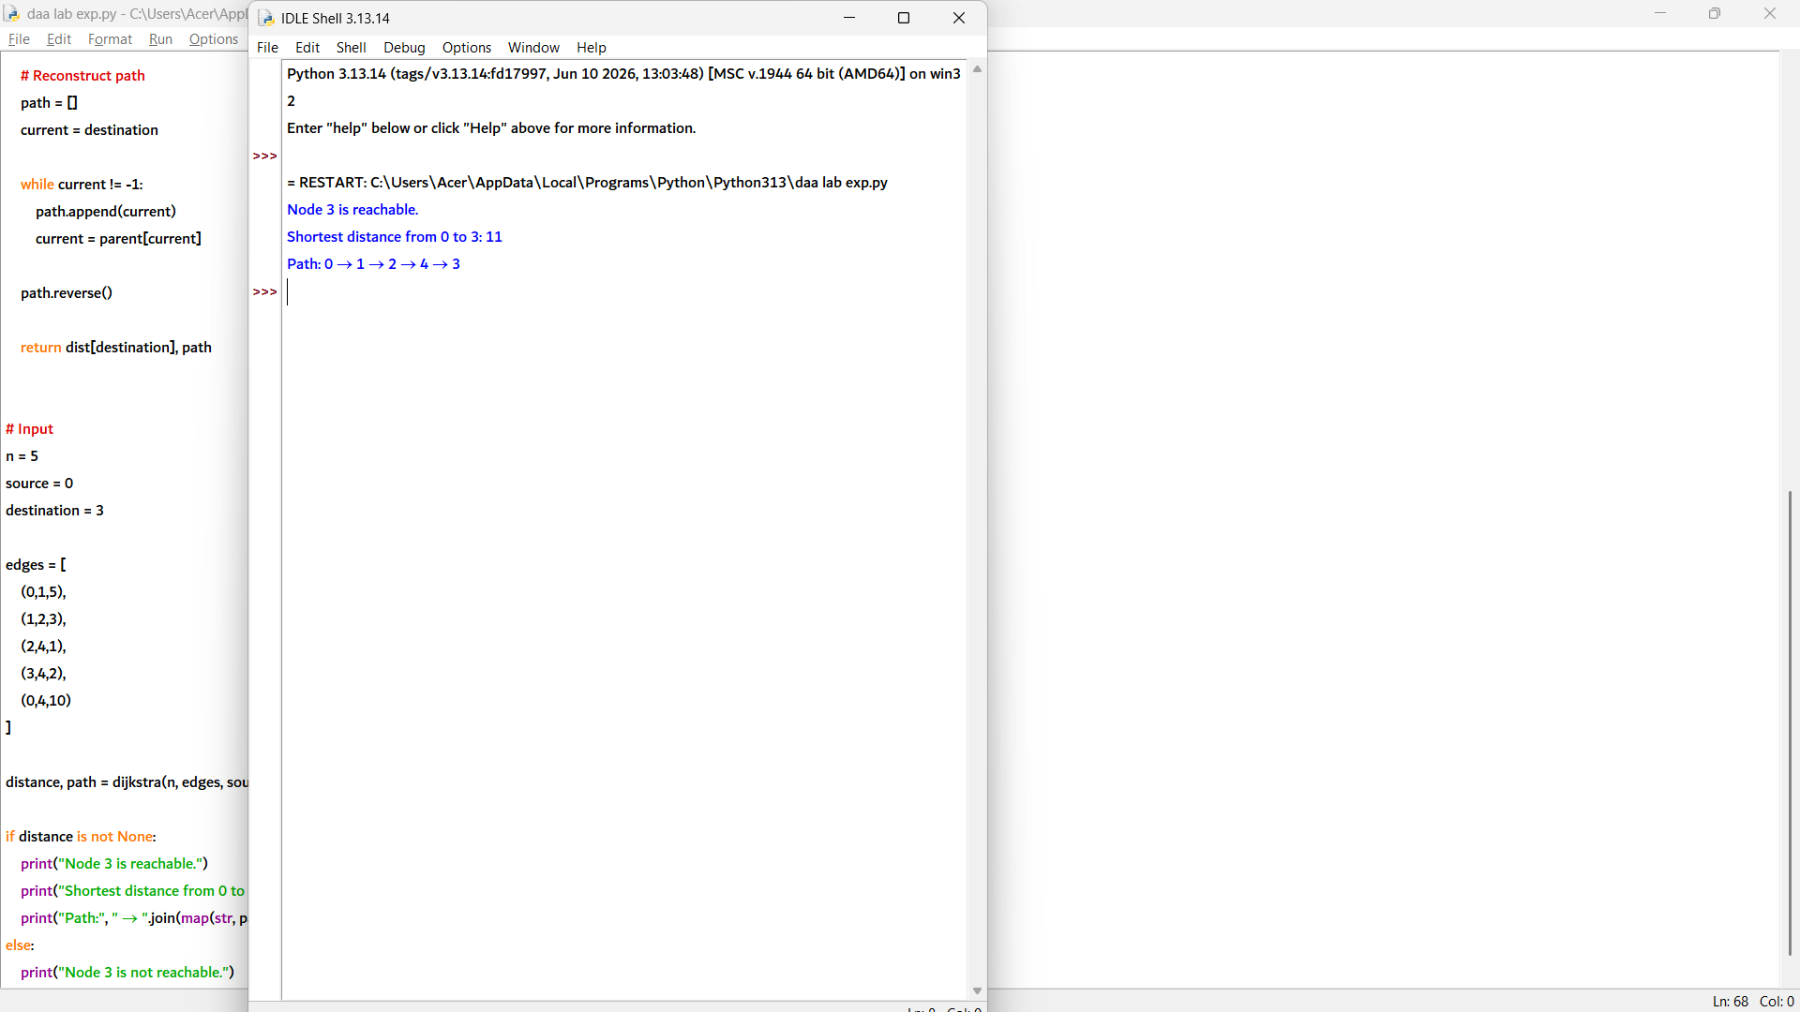

5. import heapq

def dijkstra(n, edges, source):
graph = [[] for _ in range(n)]

# Create directed graph
for u, v, w in edges:
graph[u].append((v, w))

dist = [float('inf')] * n
parent = [-1] * n

dist[source] = 0

pq = [(0, source)]

while pq:
current_dist, u = heapq.heappop(pq)

if current_dist > dist[u]:
continue

for v, weight in graph[u]:
if dist[u] + weight < dist[v]:
dist[v] = dist[u] + weight
parent[v] = u
heapq.heappush(pq, (dist[v], v))

return dist, parent

def get_path(parent, vertex):
path = []

while vertex != -1:
path.append(vertex)
vertex = parent[vertex]

return path[::-1]

# Input
n = 6
source = 0

edges = [
(0,1,2),
(0,2,4),
(1,2,1),
(1,3,7),
(2,4,3),
(3,5,1),
(4,3,2),
(4,5,5)
]

distances, parent = dijkstra(n, edges, source)

# Find hardest vertex (maximum shortest distance)
hardest = 0

for i in range(n):
if distances[i] > distances[hardest]:
hardest = i

print("Distances:", distances)
print("Hardest vertex to reach:", hardest)
print("Distance =", distances[hardest])
print("Path to", hardest, ":", " → ".join(map(str, get_path(parent, hardest))))

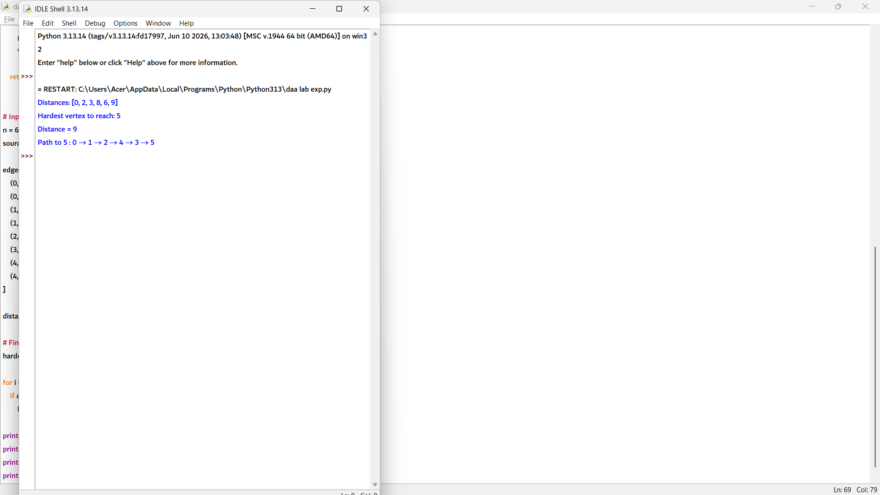

1. def kruskal(n, edges):
# Sort edges by weight
edges.sort(key=lambda x: x[2])

parent = [i for i in range(n)]

# Find parent of a node
def find(x):
if parent[x] != x:
parent[x] = find(parent[x])
return parent[x]

# Union two sets
def union(a, b):
root_a = find(a)
root_b = find(b)

if root_a != root_b:
parent[root_b] = root_a
return True

return False

mst = []
total_weight = 0

for u, v, w in edges:
if union(u, v):
mst.append((u, v, w))
total_weight += w

if len(mst) == n - 1:
break

return mst, total_weight

# Input
n = 4

edges = [
(0,1,10),
(0,2,6),
(0,3,5),
(1,3,15),
(2,3,4)
]

mst, weight = kruskal(n, edges)

print("Edges in MST:", mst)
print("Total weight of MST:", weight)

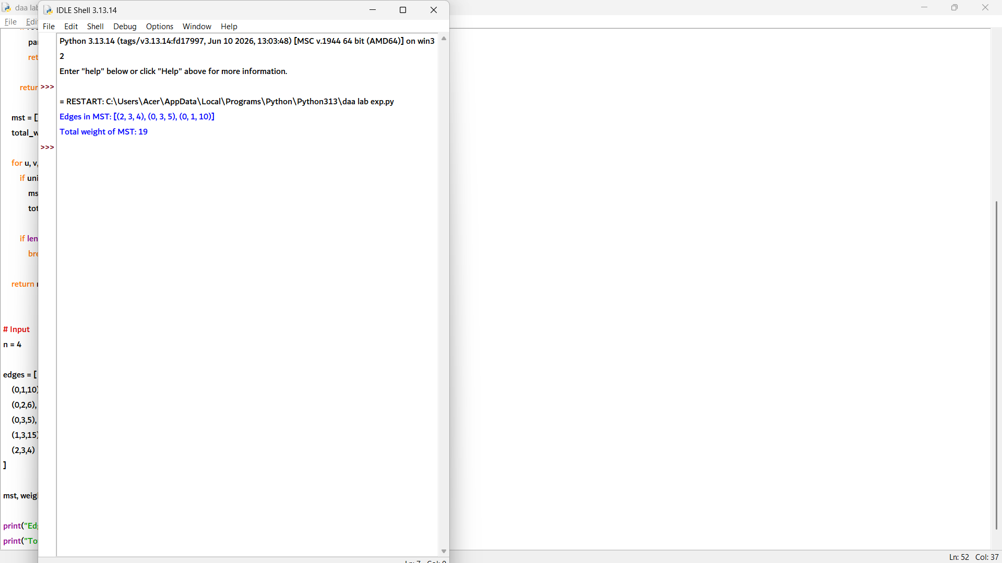

2. def kruskal(n, edges):
# Sort by weight, then smaller source vertex for tie-breaking
edges.sort(key=lambda x: (x[2], x[0]))

parent = [i for i in range(n)]

# Find parent
def find(x):
if parent[x] != x:
parent[x] = find(parent[x])
return parent[x]

# Union operation
def union(a, b):
root_a = find(a)
root_b = find(b)

if root_a != root_b:
parent[root_b] = root_a
return True

return False

mst = []
total_weight = 0

for u, v, w in edges:
if union(u, v):
mst.append((u, v, w))
total_weight += w

if len(mst) == n - 1:
break

return mst, total_weight

# Input
n = 5

edges = [
(0,1,2),
(0,3,6),
(1,2,3),
(1,3,8),
(1,4,5),
(2,4,7),
(3,4,9)
]

mst, weight = kruskal(n, edges)

print("Edges in MST:", mst)
print("Total weight of MST:", weight)

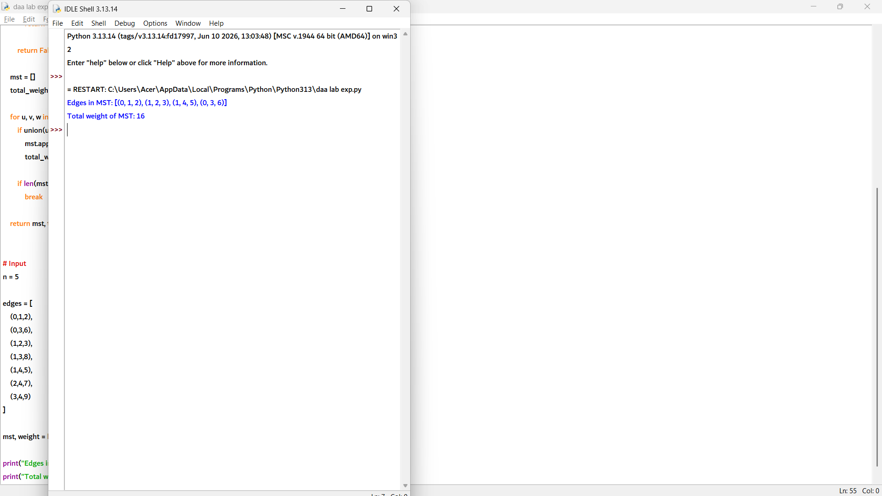

3. def kruskal(n, edges):
# Sort edges by weight
edges.sort(key=lambda x: x[2])

parent = [i for i in range(n)]

def find(x):
if parent[x] != x:
parent[x] = find(parent[x])
return parent[x]

def union(a, b):
root_a = find(a)
root_b = find(b)

if root_a != root_b:
parent[root_b] = root_a
return True
return False

mst = []
total_weight = 0

for u, v, w in edges:
if union(u, v):
mst.append((u, v, w))
total_weight += w

if len(mst) == n - 1:
break

return mst, total_weight

# Original graph
n = 6

edges = [
(0,1,4),
(0,2,3),
(1,2,1),
(1,3,2),
(2,3,4),
(3,4,2),
(4,5,6),
(3,5,5)
]

mst1, weight1 = kruskal(n, edges.copy())

print("Original MST weight:", weight1)
print("Edges:", mst1)

# Add new edge (1,5,1)
edges.append((1,5,1))

mst2, weight2 = kruskal(n, edges)

print("\nAfter adding (1,5,1):")
print("New MST weight:", weight2)
print("Edges:", mst2)

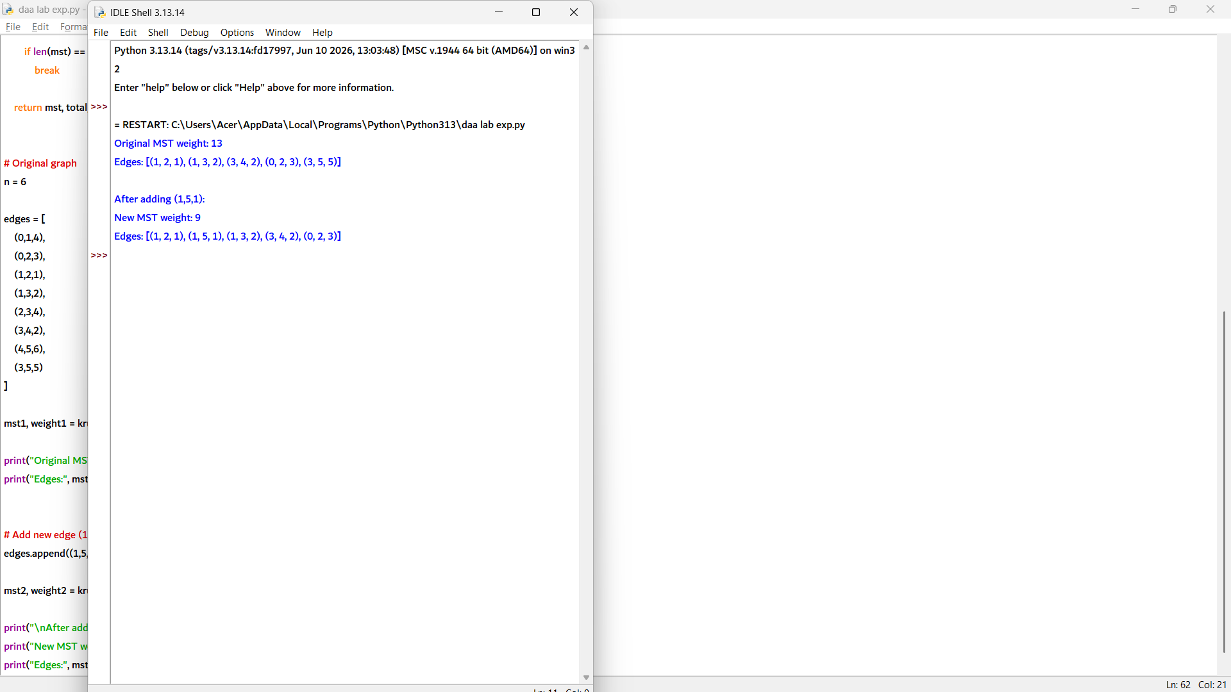

4. def kruskal_forest(n, edges):
parent = [i for i in range(n)]

def find(x):
if parent[x] != x:
parent[x] = find(parent[x])
return parent[x]

def union(a, b):
root_a = find(a)
root_b = find(b)

if root_a != root_b:
parent[root_b] = root_a
return True
return False

# Sort edges by weight
edges.sort(key=lambda x: x[2])

mst_edges = []
total_weight = 0

for u, v, w in edges:
# Ignore self loops
if u != v and union(u, v):
mst_edges.append((u, v, w))
total_weight += w

# Group MST edges by connected component
components = {}

for edge in mst_edges:
u, v, w = edge
root = find(u)

if root not in components:
components[root] = []

components[root].append(edge)

return components, total_weight

# Input
n = 7

edges = [
(0,1,3),
(0,2,5),
(1,2,2),
(3,4,4),
(3,5,6),
(4,5,1),
(6,6,0)
]

components, total = kruskal_forest(n, edges)

count = 1

for comp in components.values():
print("Component", count, "MST edges:", comp)
print("Weight:", sum(edge[2] for edge in comp))
count += 1

print("Component 3: isolated vertex 6")
print("Total MST (spanning forest) weight:", total)

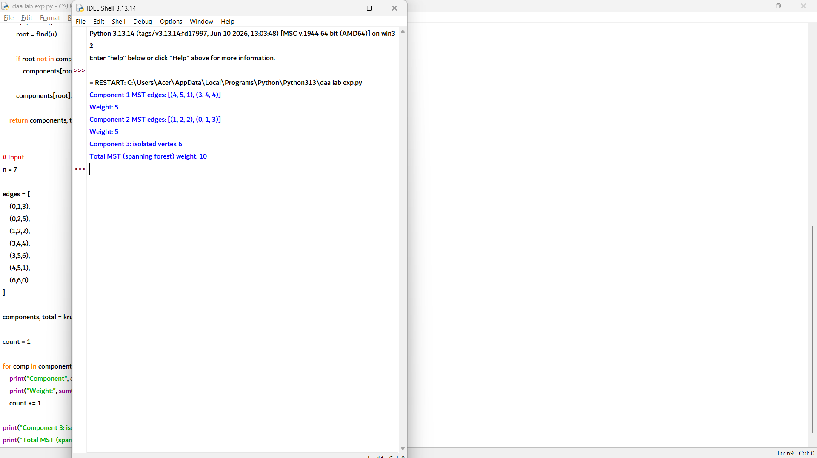

5. def kruskal(n, edges):
parent = [i for i in range(n)]

def find(x):
if parent[x] != x:
parent[x] = find(parent[x])
return parent[x]

def union(a, b):
ra = find(a)
rb = find(b)

if ra != rb:
parent[rb] = ra
return True
return False

mst = []
weight = 0

for u, v, w in sorted(edges, key=lambda x: x[2]):
if union(u, v):
mst.append((u, v, w))
weight += w

if len(mst) == n - 1:
break

return mst, weight

def find_swap(mst, non_mst):
# Find the most expensive edge in MST
expensive = max(mst, key=lambda x: x[2])

# Choose minimum weight non-MST edge
best = min(non_mst, key=lambda x: x[2])

new_weight = sum(edge[2] for edge in mst) - expensive[2] + best[2]

return best, expensive, new_weight

# Input
n = 5

edges = [
(0,1,1),
(0,2,5),
(1,2,3),
(1,3,4),
(2,3,2),
(2,4,6),
(3,4,7),
(0,4,9)
]

mst, weight = kruskal(n, edges)

# Find non-MST edges
non_mst = [e for e in edges if e not in mst]

best_add, remove_edge, new_weight = find_swap(mst, non_mst)

print("MST edges:", mst)
print("MST weight:", weight)

print("Non-MST edges:", non_mst)

print("Best swap: add", best_add,
"remove", remove_edge)

print("New MST weight:", new_weight)

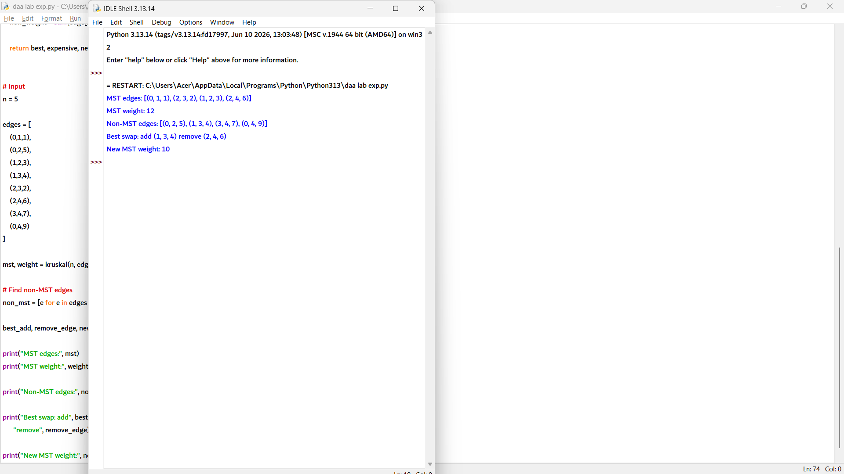

- 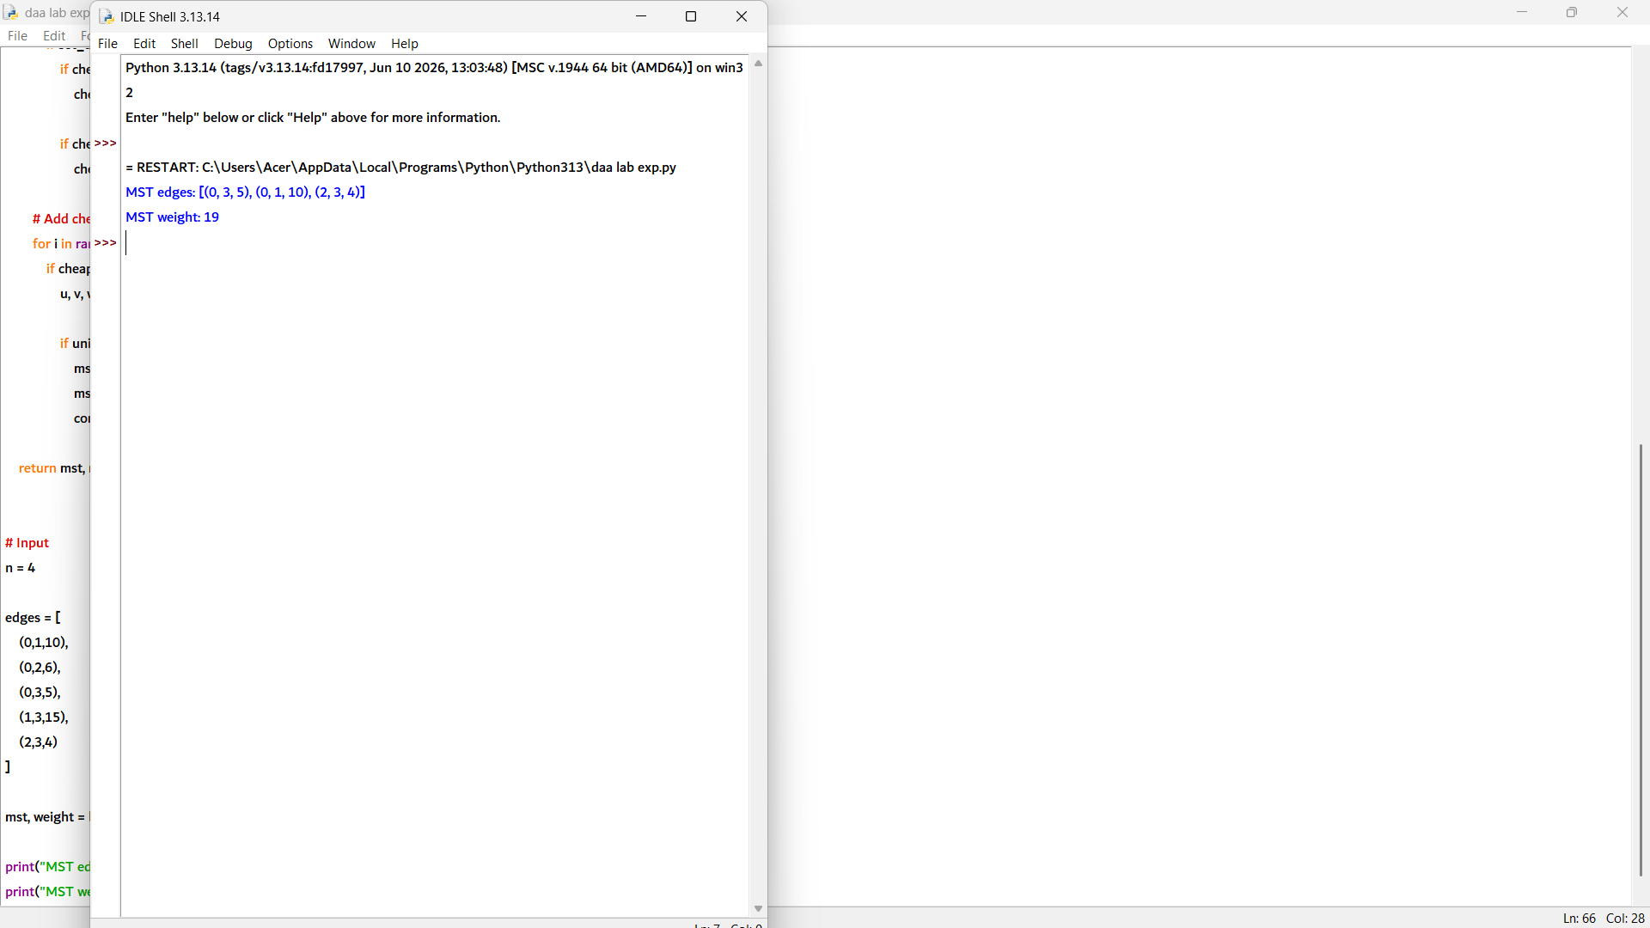

2. def boruvka(n, edges):
parent = [i for i in range(n)]

def find(x):
if parent[x] != x:
parent[x] = find(parent[x])
return parent[x]

def union(a, b):
root_a = find(a)
root_b = find(b)

if root_a != root_b:
parent[root_b] = root_a
return True
return False

mst = []
total_weight = 0
components = n
phase = 1

while components > 1:
cheapest = [-1] * n
added = []

# Find cheapest outgoing edge for each component
for i, (u, v, w) in enumerate(edges):
cu = find(u)
cv = find(v)

if cu != cv:
if cheapest[cu] == -1 or edges[cheapest[cu]][2] > w:
cheapest[cu] = i

if cheapest[cv] == -1 or edges[cheapest[cv]][2] > w:
cheapest[cv] = i

# Add selected edges
for i in range(n):
if cheapest[i] != -1:
u, v, w = edges[cheapest[i]]

if union(u, v):
mst.append((u, v, w))
added.append((u, v, w))
total_weight += w
components -= 1

print("Phase", phase, "edges added:", added)
phase += 1

return mst, total_weight

# Input
n = 5

edges = [
(0,1,2),
(0,3,6),
(1,2,3),
(1,3,8),
(1,4,5),
(2,4,7),
(3,4,9)
]

mst, weight = boruvka(n, edges)

print("MST:", mst)
print("Weight:", weight)

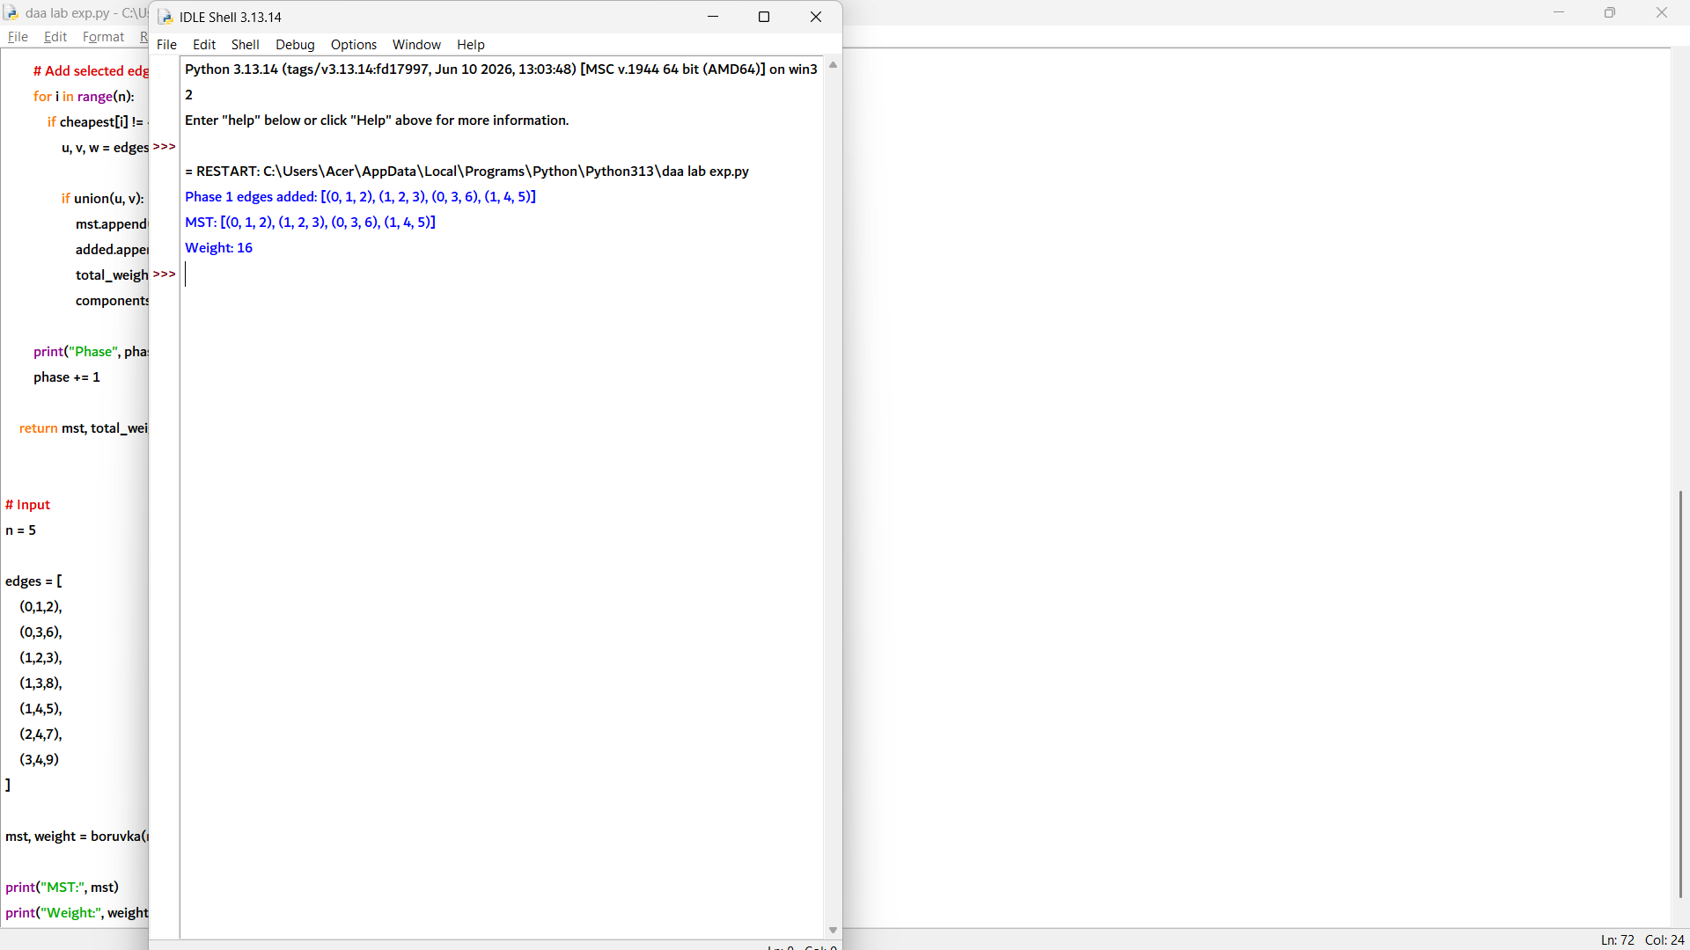

3. def boruvka(n, edges):
parent = [i for i in range(n)]

def find(x):
if parent[x] != x:
parent[x] = find(parent[x])
return parent[x]

def union(a, b):
root_a = find(a)
root_b = find(b)

if root_a != root_b:
parent[root_b] = root_a
return True
return False

mst = []
weight = 0
components = n
phase = 1

while components > 1:
cheapest = [-1] * n
added = []

# Find cheapest edge for each component
for i, (u, v, w) in enumerate(edges):
cu = find(u)
cv = find(v)

if cu != cv:
if cheapest[cu] == -1 or edges[cheapest[cu]][2] > w:
cheapest[cu] = i

if cheapest[cv] == -1 or edges[cheapest[cv]][2] > w:
cheapest[cv] = i

# Add cheapest edges
for i in range(n):
if cheapest[i] != -1:
u, v, w = edges[cheapest[i]]

if union(u, v):
mst.append((u, v, w))
added.append((u, v, w))
weight += w
components -= 1

print("Phase", phase)
print("Edges added:", added)
print("Parent array:", parent)
print()

phase += 1

return mst, weight

# Input
n = 6

edges = [
(0,1,4),
(0,2,3),
(1,2,1),
(1,3,2),
(2,3,4),
(3,4,2),
(4,5,6),
(3,5,5),
(0,5,9)
]

mst, weight = boruvka(n, edges)

print("MST edges:", mst)
print("MST weight:", weight)

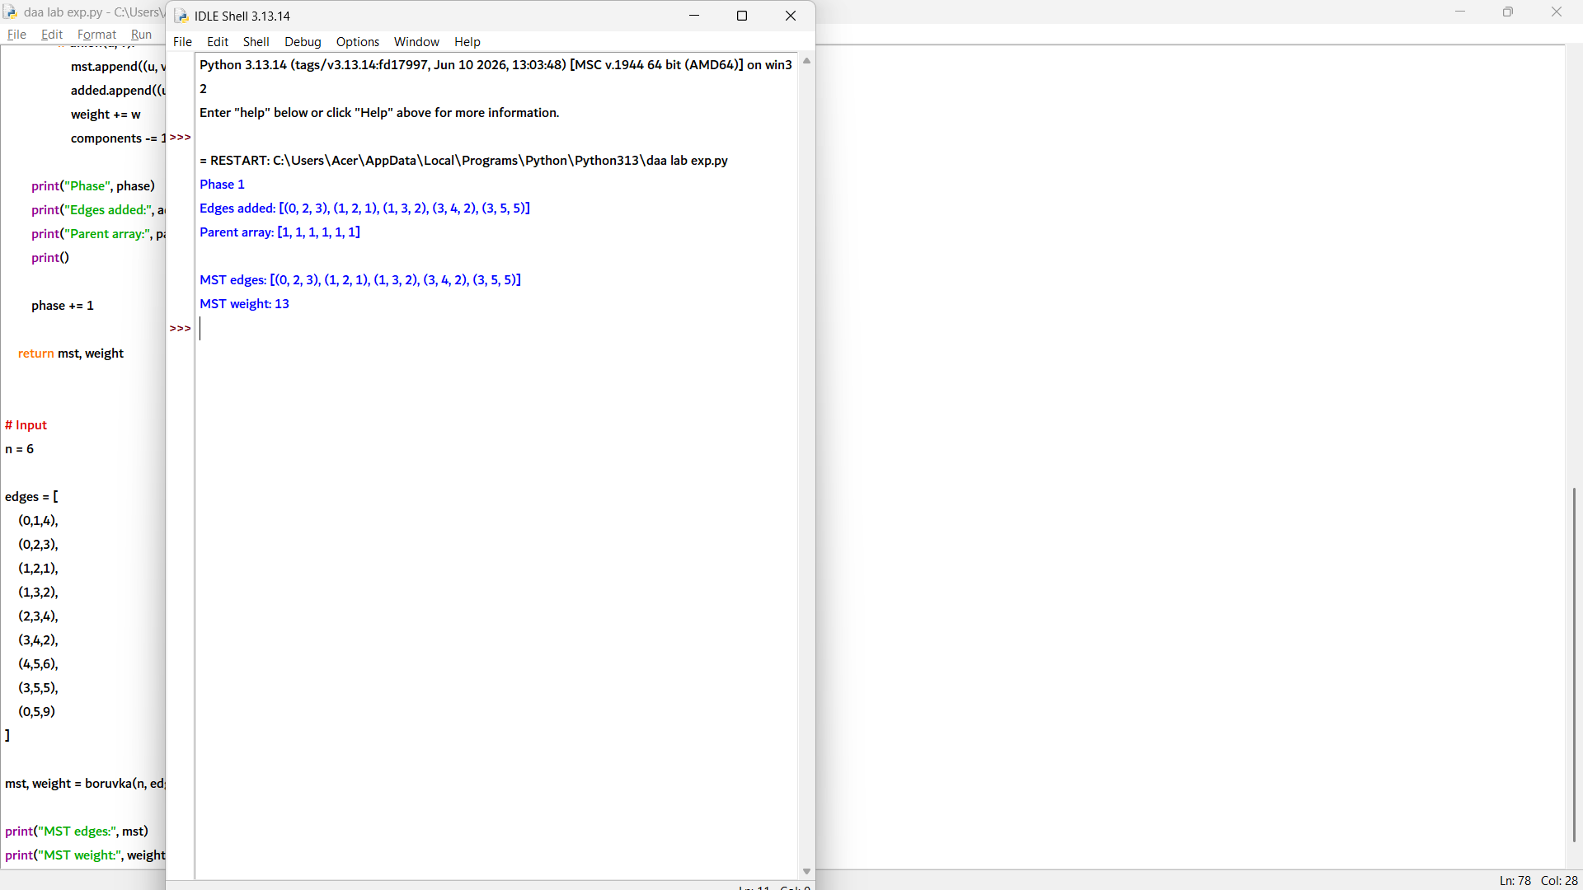

4. def boruvka(n, edges):
parent = [i for i in range(n)]

def find(x):
if parent[x] != x:
parent[x] = find(parent[x])
return parent[x]

def union(a, b):
ra = find(a)
rb = find(b)

if ra != rb:
parent[rb] = ra
return True
return False

mst = []
weight = 0
components = n
phase = 1

while components > 1:
cheapest = [-1] * n
added = []

# Find cheapest edge for each component
# If weights are equal, first encountered edge is kept
for i, (u, v, w) in enumerate(edges):
cu = find(u)
cv = find(v)

if cu != cv:

if cheapest[cu] == -1 or edges[cheapest[cu]][2] > w:
cheapest[cu] = i

if cheapest[cv] == -1 or edges[cheapest[cv]][2] > w:
cheapest[cv] = i

# Add selected edges
for i in range(n):
if cheapest[i] != -1:
u, v, w = edges[cheapest[i]]

if union(u, v):
mst.append((u, v, w))
added.append((u, v, w))
weight += w
components -= 1

print("Phase", phase, "Edges added:", added)
phase += 1

return mst, weight

# Input
n = 4

edges = [
(0,1,5),
(0,2,5),
(1,2,3),
(1,3,4),
(2,3,4),
(0,3,8)
]

mst, weight = boruvka(n, edges)

print("\nMST:", mst)
print("Weight:", weight)

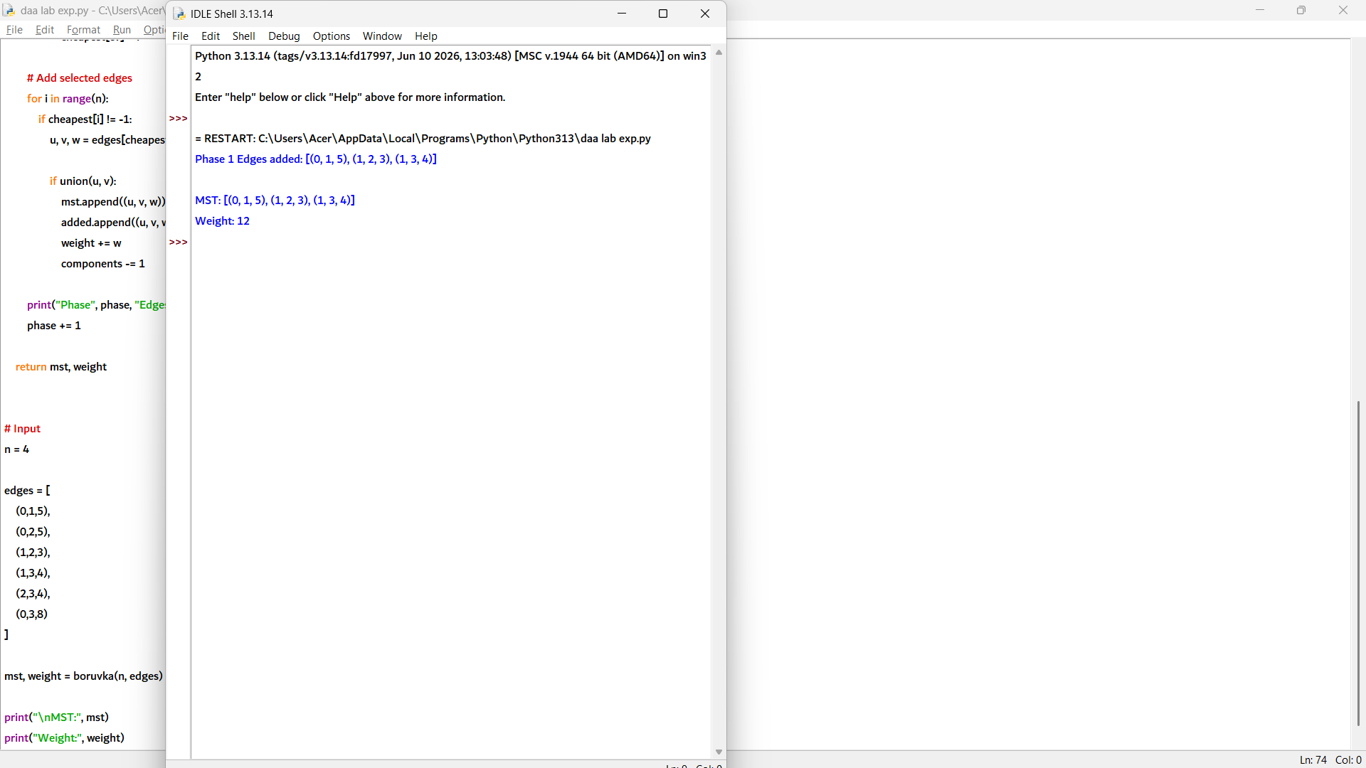

5. def kruskal(n, edges):
parent = list(range(n))

def find(x):
if parent[x] != x:
parent[x] = find(parent[x])
return parent[x]

def union(a, b):
ra = find(a)
rb = find(b)

if ra != rb:
parent[rb] = ra
return True
return False

mst = []
weight = 0

for u, v, w in sorted(edges, key=lambda x: x[2]):
if union(u, v):
mst.append((u, v, w))
weight += w

if len(mst) == n - 1:
break

return mst, weight

def prim(n, edges):
graph = [[] for _ in range(n)]

for u, v, w in edges:
graph[u].append((v, w))
graph[v].append((u, w))

visited = [False] * n
mst = []
weight = 0

visited[0] = True

for _ in range(n - 1):
minimum = float('inf')
x = y = -1

for i in range(n):
if visited[i]:
for j, w in graph[i]:
if not visited[j] and w < minimum:
minimum = w
x, y = i, j

mst.append((x, y, minimum))
weight += minimum
visited[y] = True

return mst, weight

# Input
n = 6

edges = [
(0,1,6),
(0,2,1),
(0,3,5),
(1,2,5),
(1,4,3),
(2,3,5),
(2,4,6),
(2,5,4),
(3,5,2),
(4,5,6)
]

mst_k, weight_k = kruskal(n, edges)
mst_p, weight_p = prim(n, edges)

print("Kruskal MST:", mst_k)
print("Weight:", weight_k)

print("\nPrim MST:", mst_p)
print("Weight:", weight_p)

